**LAB ACTIVITIES**

Name: Kulsoom Khurshid

Reg#: Sp20-BCS-044

Course: Operating System

**Activity 1:**

This activity is related to file permission. Perform the following tasks​

1. Create a file “testfile.txt” in /test directory​

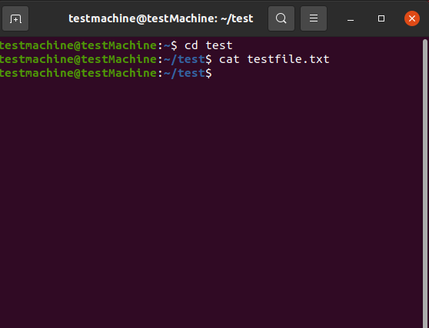

1. View and read the file using less command​

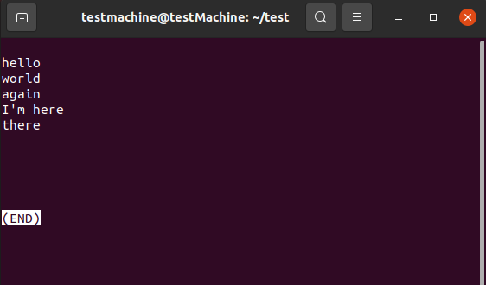

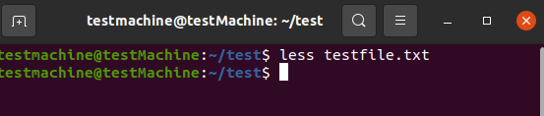

1. Use wc command to print lines, words and bytes​

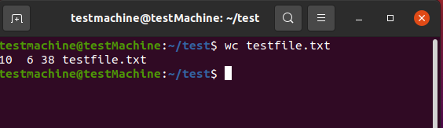

1. Find any text pattern in the file using grep​

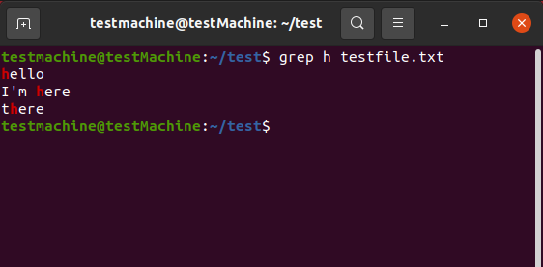

1. Print the first 3 lines of the file using head​

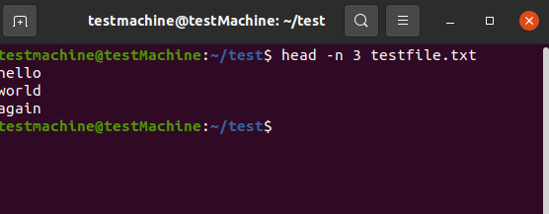

1. Print the last 3 lines of the file using tail​

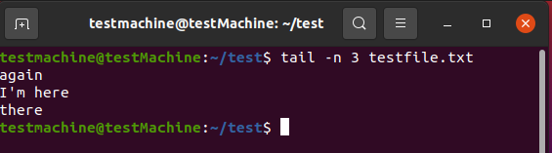

**Activity 2:**

Perform the following tasks​

1. Find all the files with extension txt in the /test directory​

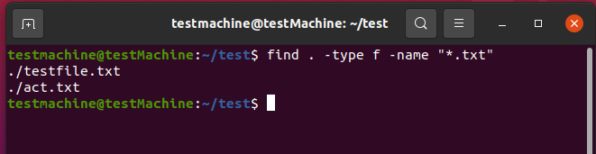

1. Find the first line of the list of files in the /test directory​

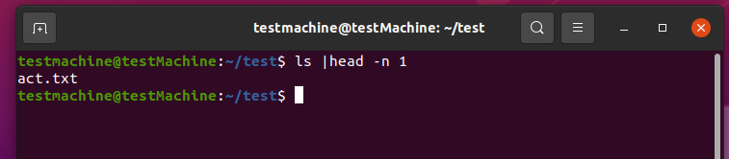

1. Find the last line of the list of files in the /test directory​

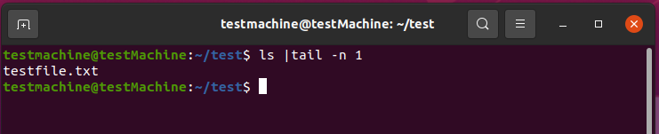

1. Produce and view a single sorted list of files by combining two directories: /Desktop​ and /bin ​

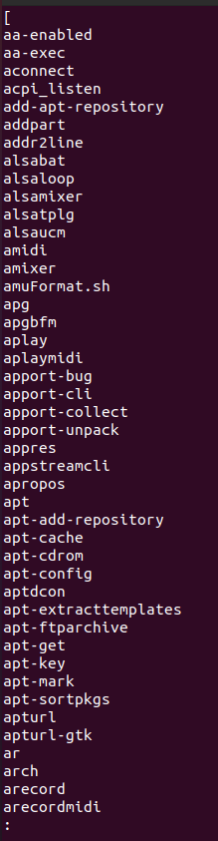

**Activity 3:**

Perform the following tasks​

1. Examine the network using Ping command and view the performance statistics.

